Matthew 1
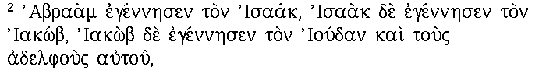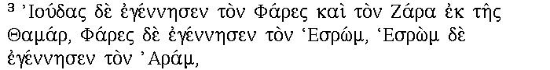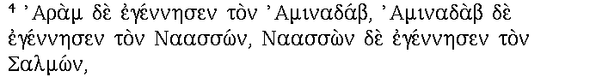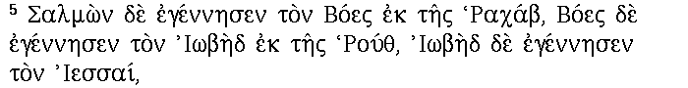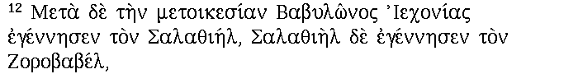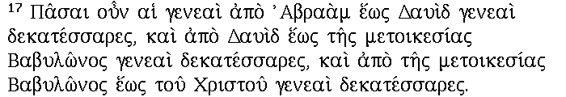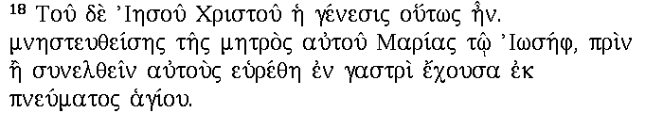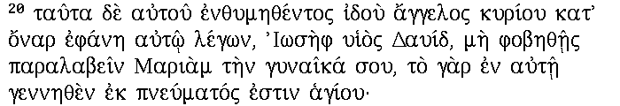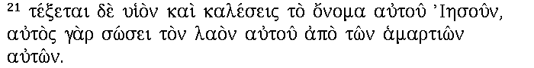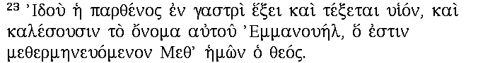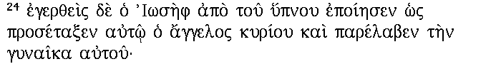

Time: 0.000 s cpu, 0.000 s real

